DSAA Computer Assignment – I

Adwait Thattey
S20170010004
Section-A

Note: The images, sound_file, output graphs are submitted with the pdf and also put in the pdf

PTO->

Q1:
a. File name: addy.jpeg (see files)
b. Independent Variables : 2 : x and y
c. Number of Components = 3, RGB
d.
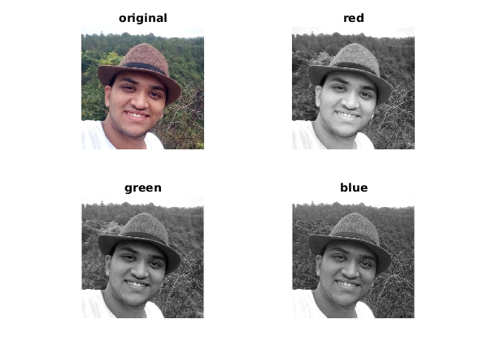

* | Red | Green | Blue
Min | 0 | 0 | 1
Max | 255 | 255 | 255
Mean | 129.0106 | 118.3826 | 115.3134

e.
* | Red | Green | Blue
Min | 0 | 0 | 1
Max | 255 | 255 | 255
Mean | 129.0106 | 118.3826 | 115.3134

f. Size: 640x640 px

Q2.
a. File: addy.wav
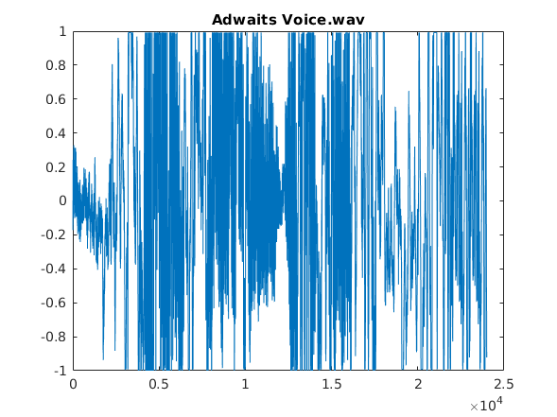

b. 1 channel
c. analog
d. 24000
e. 8.0084e+03

P.T.O. ->
Q3.

Code:

clear
clc

function y = q3Func(t)
y(t<0) = 0;
y(t>0) = 1;
return;

t = -15:0.001:15;

y = q3Func(t);
subplot(2,2,1);
plot(t,y);
grid on;
title('u(t)');
xlabel('t');
ylabel('y');
ylim([-1,2]);
xticks(-15:5:15);

y = q3Func(t - 5) - q3Func(t - 10);
subplot(2,2,2);
plot(t,y);
grid on;
title('u(t-5) - u(t-10)');
xlabel('t');
ylabel('y');
ylim([-1,2]);
xticks(-15:5:15);

y = q3Func(2 - t) - q3Func(6 - t);
subplot(2,2,3);
plot(t,y);
grid on;
title('u(2 - t) - u(6 - t)');
xlabel('t');
ylabel('y');
ylim([-1,2]);
xticks(-14:2:14);

y = q3Func(7 - t);
subplot(2,2,4);
plot(t,y);
grid on;
title('u(7 - t)');
xlabel('t');
ylabel('y');
ylim([-1,2]);
xticks(-14:3.5:14);
Output:
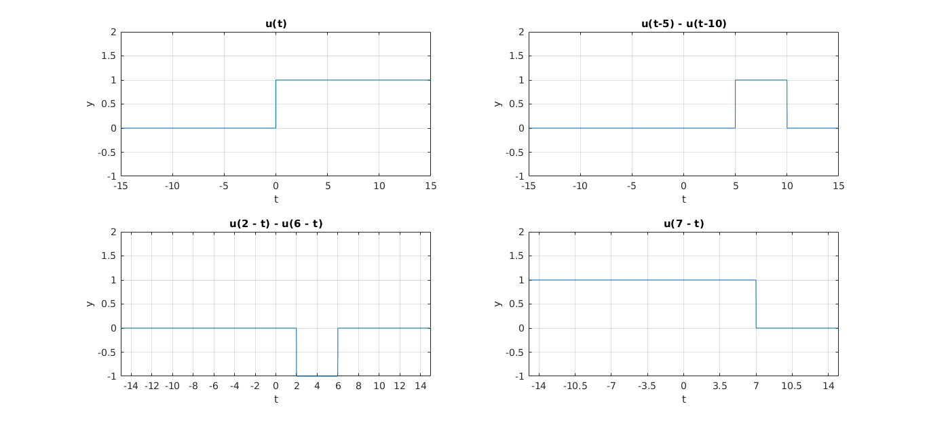

PTO ->

Q4.

Code:

clc
clear

function y = q4Func(t)
y = t;
y(t<0) = 0;
return;

t = -15:0.01:15;

y = q4Func(t);
subplot(2,2,1);
plot(t,y);
grid on;
title('r(t)');
xlabel('t');
ylabel('y');
ylim([-1,20]);
xticks(-20:2:20);

y = q4Func(t - 3);
subplot(2,2,2);
plot(t,y);
grid on;
title('r(t - 3)');
xlabel('t');
ylabel('y');
ylim([-1,20]);
xticks(-20:2:20);

y = q4Func(7 - t);
subplot(2,2,3);
plot(t,y);
grid on;
title('r(7 - t)');
xlabel('t');
ylabel('y');
ylim([-1,20]);
xticks(-20:2:20);

y = q4Func(1 - 3*t);
subplot(2,2,4);
plot(t,y);
grid on;
title('r(1 - 3t)');
xlabel('t');
ylabel('y');
ylim([-1,20]);
xticks(-20:2:20);

Output:

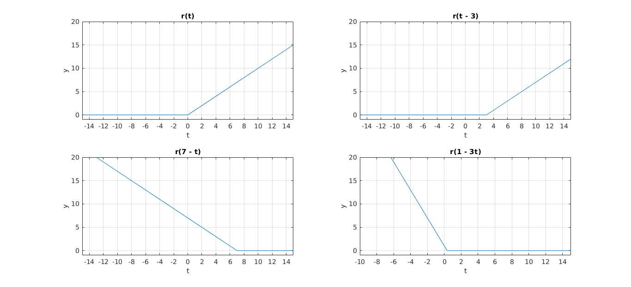

Q5.
Code:

clc
clear

omega0 = pi;
t0 = pi/2;
t = -2*pi:0.01:2*pi;

y = sin(omega0*(t - t0));
subplot(2,1,1);
plot(t,y);
grid on;
title('sin(Î©0(t âˆ’ t0 )) {Î©0 = pi, t0 = pi/2 } ');
xlabel('x');
ylabel('t');
ylim([-1.5,1.5]);
xticks(-3*pi:pi/2:3*pi);

y = sin(omega0*(t + t0));
subplot(2,1,2);
plot(t,y);
grid on;
title('sin(Î©0(t + t0 )) {Î©0 = pi, t0 = pi/2 } ');
xlabel('x');
ylabel('t');
ylim([-1.5,1.5]);
xticks(-3*pi:pi/2:3*pi);
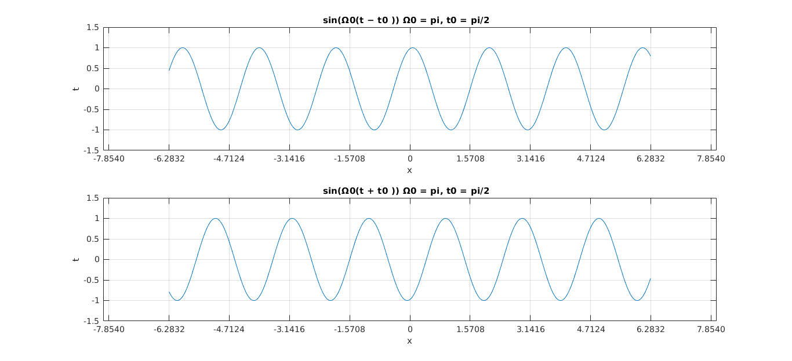
Q6.

Code:

clc
clear

function y = q6Func(t)

y=t;
y(t<0)=0;
y(t >= 1 & t < 3)=2 - y(t >= 1 & t < 3);
y(t >= 3 & t < 5)=y(t >= 3 & t < 5)-4;
y(t >= 5)=1;
return;

t = -10:0.01:10;

y = q6Func(t);
subplot(3,2,[1:2]);
plot(t,y);
grid on;
title('x(t)');
xlabel('t');
ylabel('x');
ylim([-2,2]);
xticks(-10:1:10);

y = q6Func(t-1);
subplot(3,2,3);
plot(t,y);
grid on;
title('x(t-1)');
xlabel('t');
ylabel('x');
ylim([-2,2]);
xticks(-10:1:10);

y = q6Func(t+1);
subplot(3,2,4);
plot(t,y);
grid on;
title('x(t+1)');
xlabel('t');
ylabel('x');
ylim([-2,2]);
xticks(-10:1:10);

y = q6Func(2*t - 3);
subplot(3,2,5);
plot(t,y);
grid on;
title('x(2t - 3)');
xlabel('t');
ylabel('x');
ylim([-2,2]);
xticks(-10:1:10);

y = q6Func(1 - 2*t);
subplot(3,2,6);
plot(t,y);
grid on;
title('x(1 - 2t)');
xlabel('t');
ylabel('x');
ylim([-2,2]);
xticks(-10:1:10);

Output:
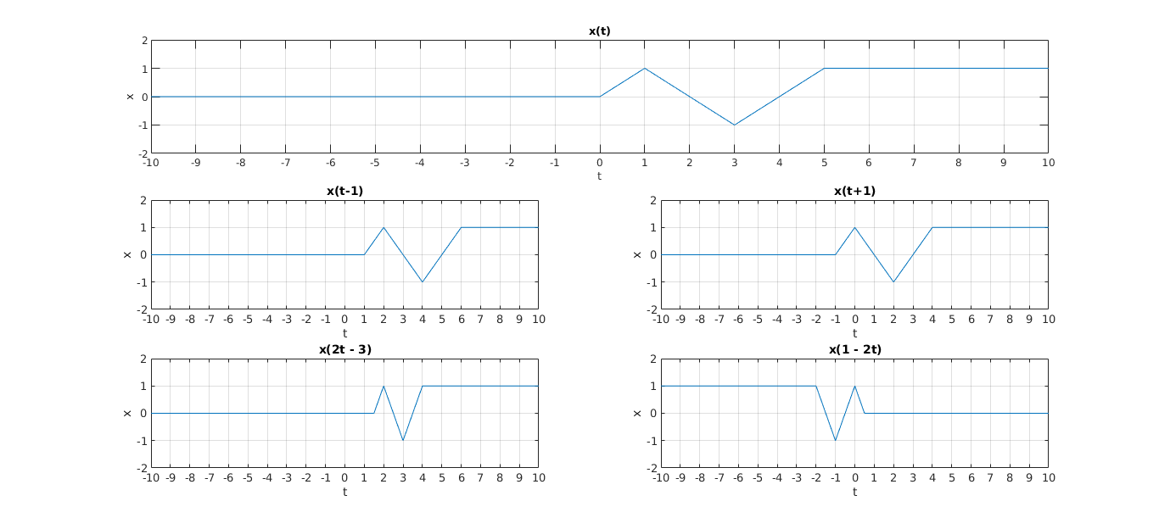

PTO->
Q7.

Code:

clear
clc

function y = q7Func(n)
y = zeros(size(n));
y(n==0) = 1;
y(n==1) = 2;
y(n==2) = 3;
y(n==3) = 8;
y(n==4) = 9;
return;

n = -6:1:6;

y = q7Func(n);
subplot(2,3,1);
stem(n,y)
grid on;
title('x[n]');
xlabel('n');
ylabel('x');
ylim([-1,10]);
xticks(-6:2:6);
yticks(-1:1:10);

y = q7Func(n - 1);
subplot(2,3,2);
stem(n,y)
grid on;
title('x[n - 1]');
xlabel('n');
ylabel('x');
ylim([-1,10]);
xticks(-6:2:6);
yticks(-1:1:10);

y = q7Func(n + 2);
subplot(2,3,3);
stem(n,y)
grid on;
title('x[n + 2]');
xlabel('n');
ylabel('x');
ylim([-1,10]);
xticks(-6:2:6);
yticks(-1:1:10);

y = q7Func(2 - n);
subplot(2,3,4);
stem(n,y)
grid on;
title('x[2 - n]');
xlabel('n');
ylabel('x');
ylim([-1,10]);
xticks(-6:2:6);
yticks(-1:1:10);

n = -6:0.5:6;

y = q7Func(1 - 2*n);
subplot(2,3,5);
stem(n,y)
grid on;
title('x[1 - 2n]');
xlabel('n');
ylabel('x');
ylim([-1,10]);
xticks(-6:1:6);
yticks(-1:1:10);

y = q7Func(2*n + 3);
subplot(2,3,6);
stem(n,y)
grid on;
title('x[2n + 3]');
xlabel('n');
ylabel('x');
ylim([-1,10]);
xticks(-6:1:6);
yticks(-1:1:10);

PTO→

Output:
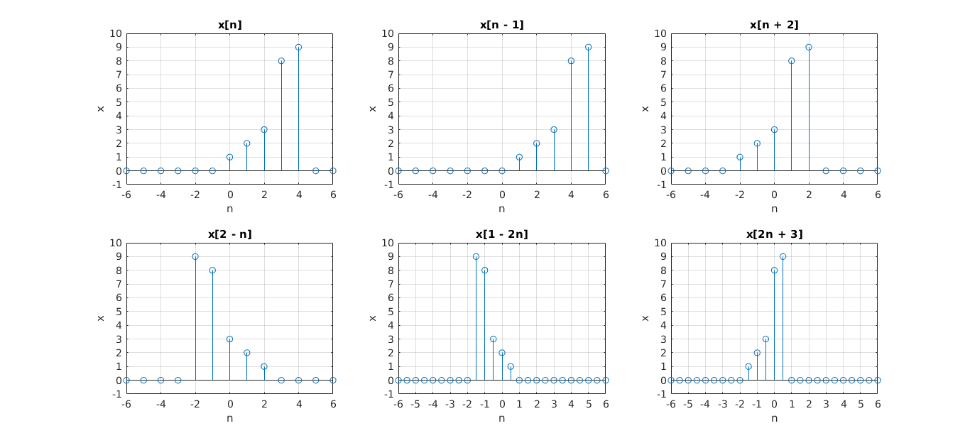
Q8.

Code:

clear
clc

t = -3:0.01:3;

y1 = q8Func(t,0,1);
y2 = q8Func(t,2,1);
y3 = q8Func(t,-2,1);

plot(t,y1);
grid on;
xticks(-3:0.5:3)
hold on;
plot(t,y2);
hold on;
plot(t,y3);
hold off;

PTO->
Output:

